Week 3
EF Core 8.0 HOL
Lab 1
What is ORM?
ORM (Object-Relational Mapping) is a technique that connects C# classes to database tables, allowing developers to work with data as objects instead of writing raw SQL.
How it maps C# classes to tables:
- Each class becomes a table.
- Each property becomes a column.
- Relationships are handled with navigation properties and foreign keys.
Benefits of ORM:
- Productivity: Write less boilerplate SQL code.
- Maintainability: Easier to update and refactor using C# code.
- Abstraction from SQL: Focus on business logic without worrying about database syntax.
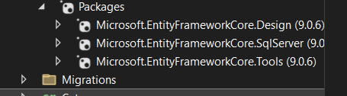

Lab 2
Category.cs-
using System.Collections.Generic;

namespace RetailInventory
{
public class Category
{
public int Id { get; set; }
public string Name { get; set; }

// One-to-many relationship
public List<Product> Products { get; set; }
}
}

Product.cs-

namespace RetailInventory
{
public class Product
{
public int Id { get; set; }
public string Name { get; set; }

public decimal Price { get; set; }

public int CategoryId { get; set; }

public required Category Category { get; set; }
}
}

AppDbContext.cs-

using Microsoft.EntityFrameworkCore;

namespace RetailInventory
{
public class AppDbContext : DbContext
{
public DbSet<Product> Products { get; set; }
public DbSet<Category> Categories { get; set; }

protected override void OnConfiguring(DbContextOptionsBuilder optionsBuilder)
{
optionsBuilder.UseSqlServer("Server=AYUSHMAN\\SQLEXPRESS;Database=RetailStoreDb;Trusted_Connection=True;Encrypt=False;");
}
}
}

LAB 3
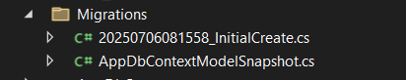
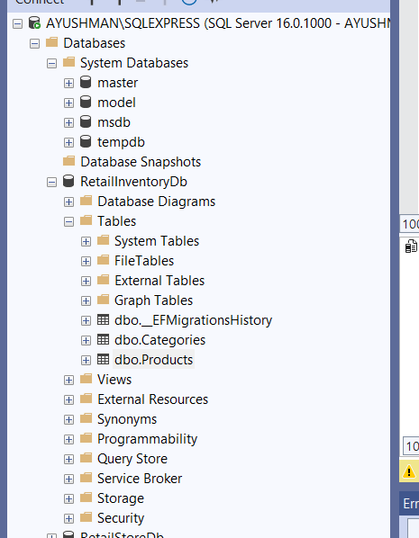

LAB 4
Program.cs-
using System;
using System.Threading.Tasks;
using Microsoft.EntityFrameworkCore;
using RetailInventory;

class Program
{
static async Task Main()
{
using var context = new AppDbContext();

// Prevent duplicate seed
if (await context.Products.AnyAsync()) return;

var electronics = new Category { Name = "Electronics", Products = new List<Product>() };
var groceries = new Category { Name = "Groceries", Products = new List<Product>() };

await context.Categories.AddRangeAsync(electronics, groceries);

var product1 = new Product { Name = "Laptop", Price = 75000, Category = electronics };
var product2 = new Product { Name = "Rice Bag", Price = 1200, Category = groceries };

await context.Products.AddRangeAsync(product1, product2);

await context.SaveChangesAsync();

Console.WriteLine("Initial data inserted successfully.");
}
}
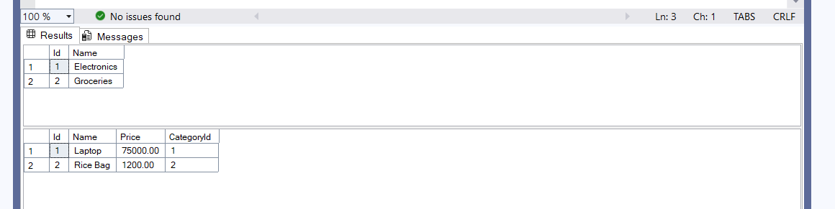

LAB 5
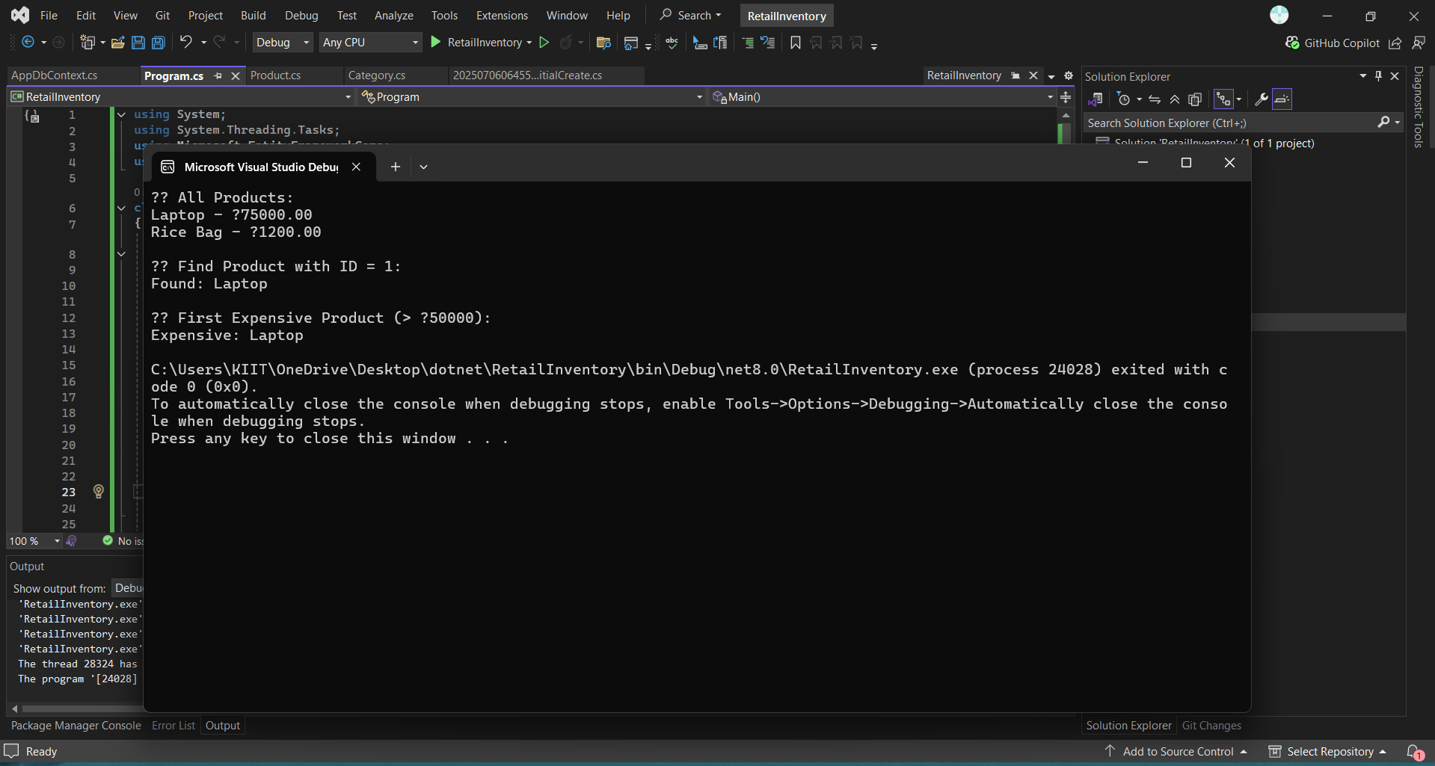

Program.cs-
using System;
using System.Threading.Tasks;
using Microsoft.EntityFrameworkCore;
using RetailInventory;

class Program
{
static async Task Main()
{
using var context = new AppDbContext();

Console.WriteLine(" All Products:");
var products = await context.Products.ToListAsync();
foreach (var p in products)
Console.WriteLine($"{p.Name} - ₹{p.Price}");

Console.WriteLine("\n Find Product with ID = 1:");
var product = await context.Products.FindAsync(1);
Console.WriteLine($"Found: {product?.Name}");

Console.WriteLine("\n First Expensive Product (> ₹50000):");
var expensive = await context.Products.FirstOrDefaultAsync(p => p.Price > 50000);
Console.WriteLine($"Expensive: {expensive?.Name}");
}

}
LAB 6-
Program.cs-
using System;
using System.Threading.Tasks;
using Microsoft.EntityFrameworkCore;
using RetailInventory;

class Program
{
static async Task Main()
{
using var context = new AppDbContext();

// Update Product Price
var product = await context.Products.FirstOrDefaultAsync(p => p.Name == "Laptop");
if (product != null)
{
Console.WriteLine($"Old Price of {product.Name}: ₹{product.Price}");
product.Price = 70000;
await context.SaveChangesAsync();
Console.WriteLine($"Updated Price of {product.Name}: ₹{product.Price}");
}

// Delete a Product
var toDelete = await context.Products.FirstOrDefaultAsync(p => p.Name == "Rice Bag");
if (toDelete != null)
{
context.Products.Remove(toDelete);
await context.SaveChangesAsync();
Console.WriteLine($"Deleted Product: {toDelete.Name}");
}
}
}
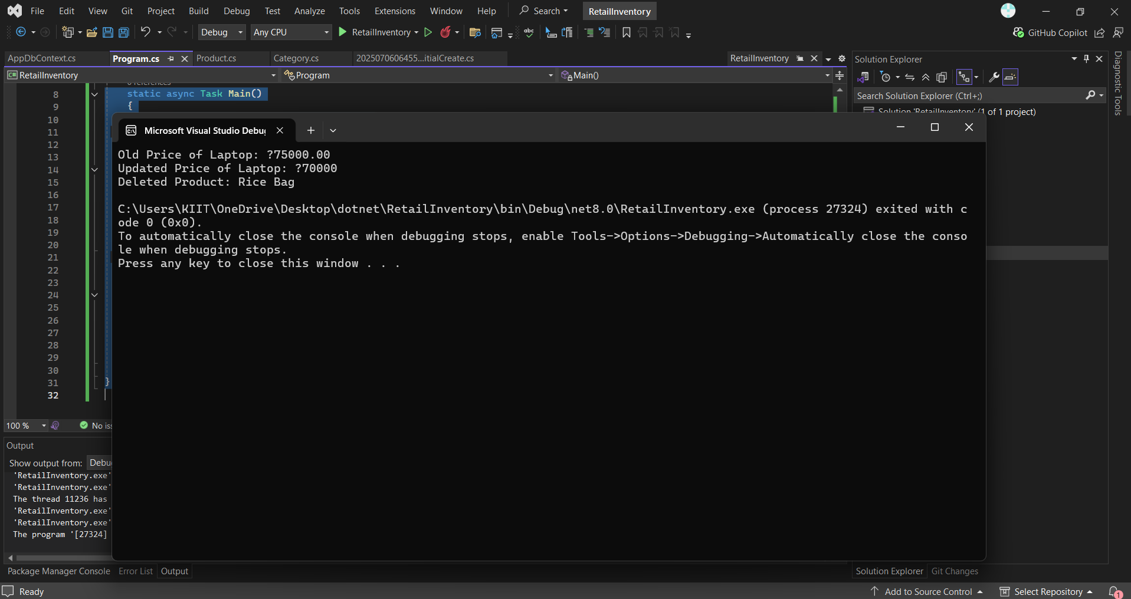

LAB 7
Program.cs-
using System;
using System.Linq;
using System.Threading.Tasks;
using Microsoft.EntityFrameworkCore;
using RetailInventory;

class Program
{
static async Task Main()
{
using var context = new AppDbContext();

//Filter and Sort Products
Console.WriteLine(" Products with Price > ₹1000 (Descending):");
var filtered = await context.Products
.Where(p => p.Price > 1000)
.OrderByDescending(p => p.Price)
.ToListAsync();

foreach (var product in filtered)
Console.WriteLine($"{product.Name} - ₹{product.Price}");

//Project into DTO
Console.WriteLine("\n Product DTOs (Name + Price Only):");
var productDTOs = await context.Products
.Select(p => new { p.Name, p.Price })
.ToListAsync();

foreach (var dto in productDTOs)
Console.WriteLine($"{dto.Name} - ₹{dto.Price}");
}
}

